Wheathampstead W.I.

Our November meeting proved a most entertaining and creative evening. There were three different crafts for us to try, or, if not feeling “crafty” there was a games table for members to enjoy with lots of chat and laughter.

We welcomed Caroline Lawrence from Rock n Wool Creations, who organised a group with ideas for hand painted greetings cards. On another table Lynsey Lloyd, known as The Dotty Crafter, demonstrated how to decorate Christmas baubles using a needle felt technique. As complete novices, eight of us really enjoyed learning this new skill. And last, but not least, we benefited from instruction by Zara Benomran of Artistic Odyssey, in the art of moulding clay to create decorative pots, trinket trays, pots with lids, and even a very fine pig money box.

All those taking part thoroughly enjoyed their chosen craft, and with the usual Raffle, and welcome refreshments, the evening sped by all too quickly.

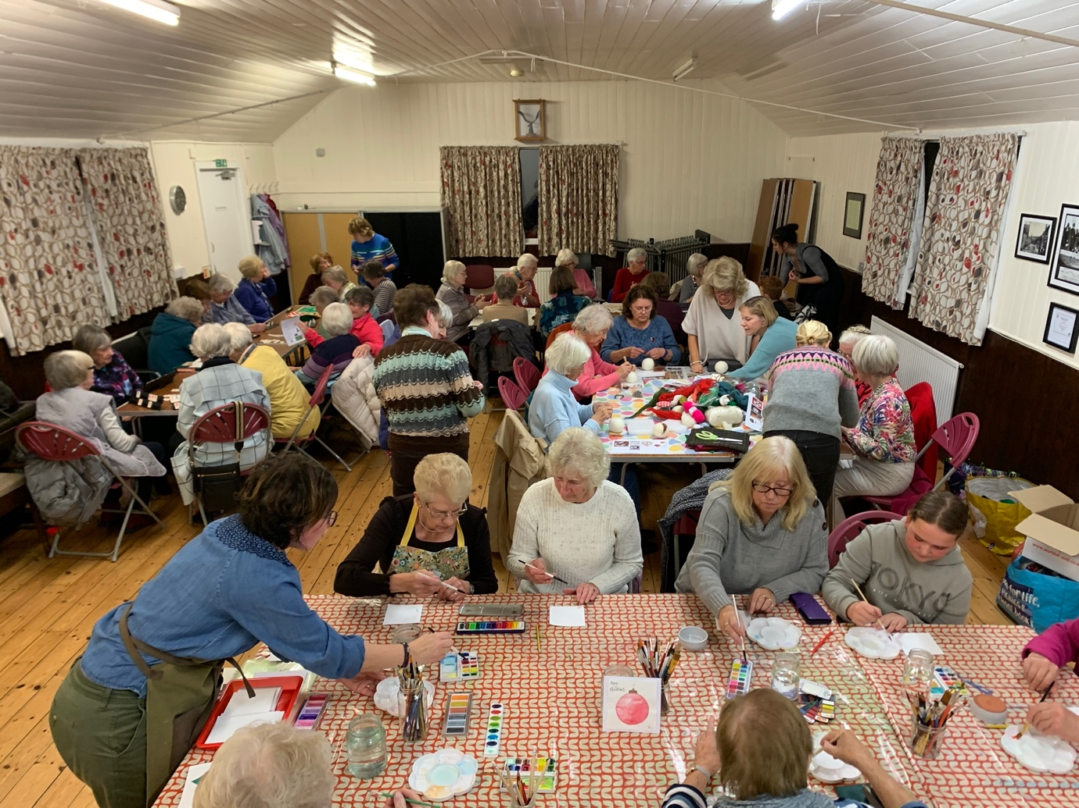

Report written by Margaret Newland

Photograph by Karen Benomran