**Wheathampstead Women’s Institute – 100 years**

In 1921 the Wheathampstead Women’s Institute was formed in a small village in Hertfordshire. This institute still meets today, on the second Wednesday of the month, at the Mead Hall in the centre of the village. The picture below shows that on March 16th, 1932, the first bricks were laid at the Mead Hall to create a venue for these meetings and for the use of the community. The land and the buildings on this site were gifted to the Wheathampstead Women’s Institute by Sir Beech Thomas for use by the community for “social, recreational and educational purposes.” To date the WI still manages the hall just as Sir Thomas requested. The hall has undergone much change over the years to ensure it is in line with current regulations and the latest was in 2019 when it was clad in UPVC to ensure the building lasts for future generations.

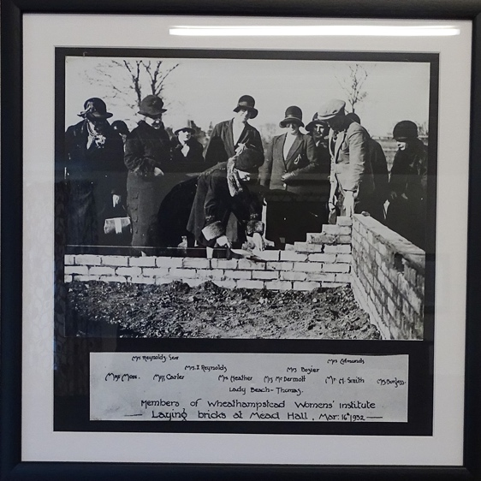

The Women’s Institute has evolved over the years but is still a place where women are able to come together and be a part of something. The activities have changed, and records show back in 1936 a picnic was arranged at No-man’s-land, Harvest Stall at the October meeting, bring and buy stall, and the need to mend the chairs with some material. In 1939 it was discussed at a meeting about the evacuated children using the hall for “entertainment and to do mending, etc”. in 1940 there were discussions about growing more food and a meeting was planned to discuss allotments with the Parish Council, Whist Drive was arranged, knitted garments for the troops, made blackout curtains for the hall, eggs given to local hospitals, plans for members to make coats for evacuees. In true WI style the Birthday party has continued every year and even during war rationing meant the birthday cake “would be made the best it could”. 1941 the hall was requisitioned by the army, but the piano was left “for the use of the troops”. In 1942 the Land Girls were invited to meetings. In 1945 at the end of the war there was discussions on how the institute could “welcome back women from the services, it was hoped that those returning may join us and bring along useful suggestions from experiences of companionship they have found in the forces”. Since the war the institute has evolved and activities have included regular performances/pantomimes put on by the members, car boot sales were arranged, the institute attended Homecraft Day winning prizes, fundraising tables at village events including school fun day, outings, fashion shows. Prior to March 2020 when the covid pandemic hit we were arranging theatre trips, coffee mornings, social afternoons, craft events, afternoon teas and attending county events put on by Hertfordshire WI.

The past 18 months have been a trial for everyone, but in true Women’s Institute style we have pulled together and made sure that our members were regularly contacted, Zoom meetings were arranged and when possible, we had some social distanced outside events. We have ensured that no one felt alone, and we have come back stronger for it. Our 100th birthday is a fitting tribute to a very hard time, and we celebrated in style at the Aldwickbury Golf Club with a sit-down meal of Salmon or Beef followed by tart, fruit salad or profiteroles and tea/coffee. The staff did an incredible job at making our celebration go with a bang. A presentation was given by Hannah, our youngest member to our longest standing member Sylvia Smith (a member since 1966) and to Angela Thonger who was celebrating her birthday (not 100 though). A big thank you to the committee for organising (Ann Chance Read - President, Karen Benomran – Secretary, Pam Sanderson – Treasurer, Kathy Sanger, Alison Wigginton, Susie Brown, Gill Keen) and especially to Susie for liaising with the golf club and for decorating the hall. We continued our celebrations into our November meeting where we celebrated with a gorgeous birthday cake which was cut by Beryl who had just celebrated her 90th birthday.

The Wheathampstead Women's Institute 100 Years


If anyone is interested in joining the Wheathampstead Women’s Institute, please contact us on wheathampsteadwi@outlook.com.

