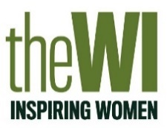
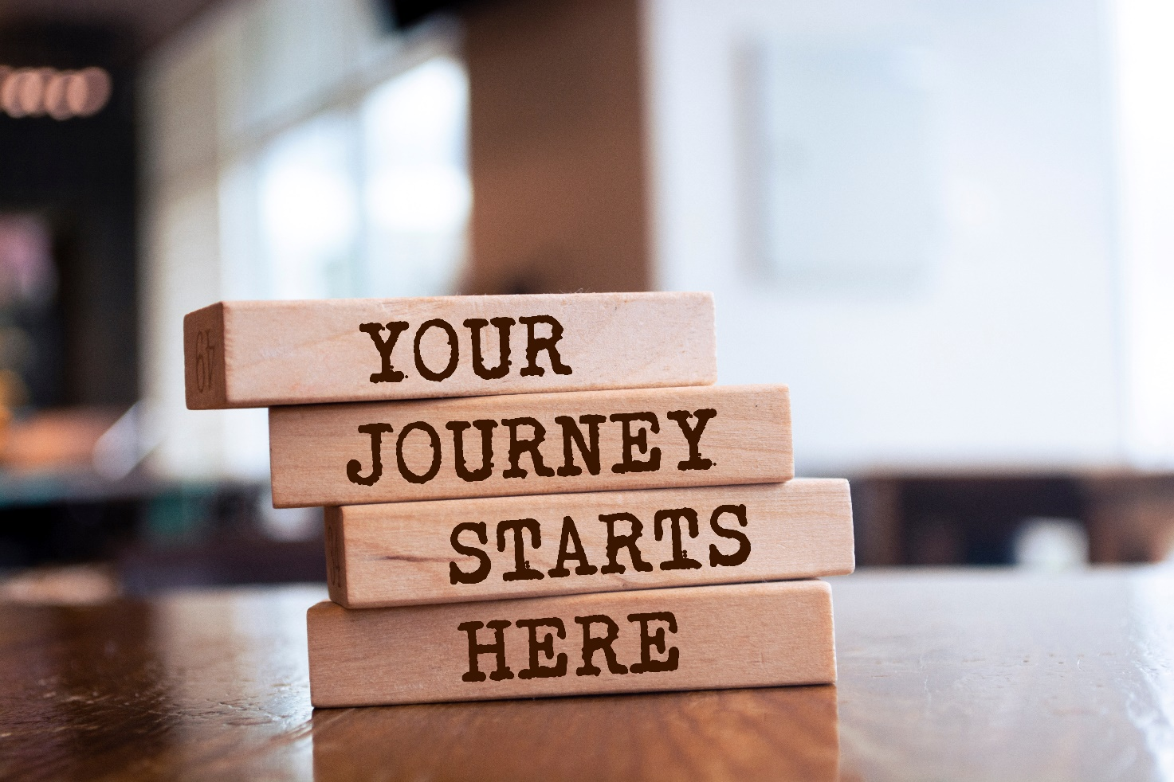

“Imagine a future WI where the WI’s educational offering reaches all members, regardless of disposable income, geographical location, or accessibility requirements, allowing all members to pursue their passion or academic goals and reach their full potential. An educational model that reaches those who have previously felt excluded from opportunities internal and external to the WI due to time and financial constraints. This is the future we see for the WI, and we are excited to be in a position where this is something we can achieve.”
Ann Jones DL, NFWI Chair
Annual Meeting, Cardiff 2023

Welcome to the WI Learning Hub

We are delighted to celebrate the International Day of Education on Wednesday 24 January 2024, and invite WI members to join us on the next steps of our educational journey via the WI Learning Hub.

Lifelong learning has always been at the very heart of the WI; it is important to everyone regardless of age, race, gender or ability. As life changes, so does the way we learn and the advancement in the technological landscape means that our approach to learning is continually changing.

The WI Learning Hub recognizes the continual changes that we all face and brings together a world of opportunities; taking users on a learning journey that is accessible, flexible and inclusive to all women and girls. Our vision is…

- To offer a variety of accessible and inclusive learning experiences, reflective and relevant to women at all stages of life.

- To provide a flexible learning pathway that propels women into pursuing their passion, skills or academic goals, empowering women to increase their self-worth, confidence and reach their full potential.

- To be a bold leading force in making learning and development convenient, safe and attractive for women, expanding knowledge and understanding both within the WI and society.

- To grow a modern, non-judgmental and inspiring learning environment which captures interest and elevates knowledge, skills and confidence for all women.

The WI Learning Hub will provide WI members with access to a range of online courses, and the majority of them will be free! There will be a small number of specialised courses delivered by external providers that will require a small fee, but these will be kept as low as possible.

As an exclusive new benefit to the annual WI membership, members will be able to choose their own learning pathway, at their own pace and at times that fit into their lifestyle. Courses will be delivered in a range of formats: daily, live courses but also pre-recorded ones so that members can enjoy them at their leisure. Some will require advance booking, but these will predominantly be for specific training courses. There will be downloadable and printable resources, a wide range of courses from crafts to cookery and wellbeing, plus quizzes and competitions!

Dates for your diary…

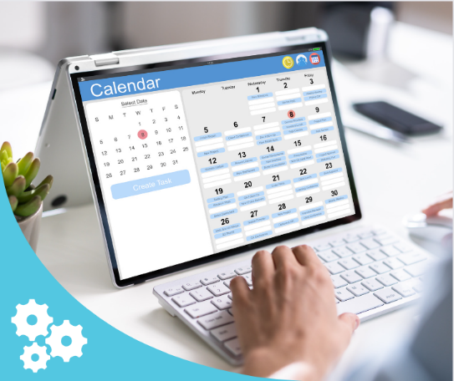
2 December 2023, sign-up to the new WI Learning Hub Newsletter to be kept up to date, weekly, with new courses, projects and activities.

WI Learning Hub Newsletter

15 December 2023, the final live course will be delivered on Denman at Home, after which the site will be closed for the Christmas break.

24 January 2024, WI Learning Hub programme opens for booking.

29 January 2024, the first courses take place on the WI Learning Hub!

Coming for 2024…
The Denman Trust Grant Scheme will be opening to federations to help deliver learning opportunities for their WIs. More details to follow in the New Year but if you want to find out a little more before then, check out the November/December issue of WI Life!

Need help or have a question? We are more than happy to help, simply contact the team on WILearningHub@nfwi.org.uk

